What Is Battery Storage?

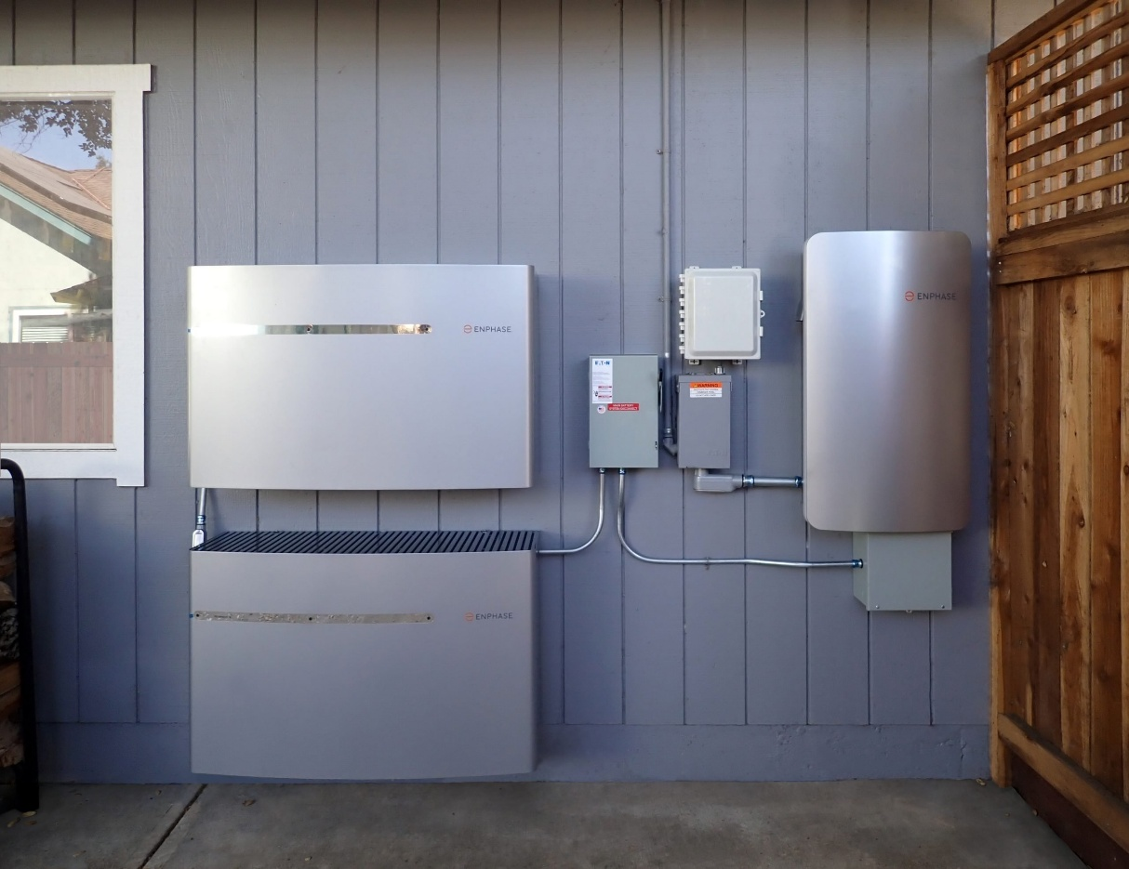
(Image source: Synsolar, “Battery Storage”)
A battery storage system stores electricity during the times of the day where there is excess or cheaper electricity available. The stored electricity can then be used at a later time, such as when there is a power outage or when the price of electricity is much higher. Battery storage systems can also store excess electricity that is generated by solar panels and other distributed energy resources (DERs).
Battery storage systems in the home are most commonly located in spaces like the garage, basement, or utility room. Typical home battery systems have a range between 5-20 kWh and can power essential appliances in a home for about 24 hours. The most common kind of home battery system type is lithium-ion, and these batteries typically have a life span of 10-15 years or 6,000 cycles.

