What is an Induction Stove?

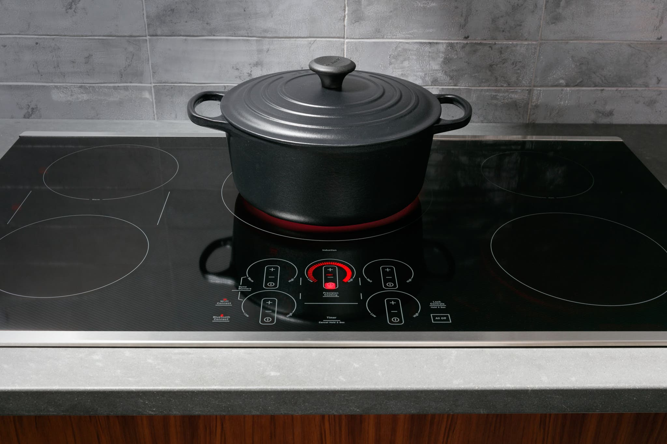(Image source: NYT Wirecutter, “Induction Cooktops”)
An induction stove is a type of stove that uses electromagnetic energy to heat the cookware directly. When an induction stove is turned on, there is a flow of electricity that is sent through copper coils underneath the stove surface. This flow of electricity creates a magnetic field above the stove surface, which heats the cookware that is placed on top of the stove.
Since the cookware is being directly heated by the induction stovetop as opposed to a regular gas or electric, this results in much faster cook times and efficient energy use. An induction stovetop can precisely control the surface temperature as well as reduce risk of burns, since the surface remains cool to the touch even when turned on. Only certain types of cookware that have a magnetic base are compatible with induction stovetop use, such as cast iron or stainless steel

